**Dr. Giles’**

**Cataract Handout**

**Pre- & Post-Operative Instructions**

**Learn more @**

**www.SurgeryWithDrGiles.com**

**What is a Cataract?**

A cataract is when your natural lens becomes cloudy (first picture). Instead of focusing light to one point in the back of your eye, your cloudy lens (aka cataract) scatters light. This may be why you are no longer able to see as well with glasses or why your vision gets worse at night. At night your pupil gets bigger and lets in more light, which scatters (glare/haloes) even more.

Your lens sits in a very thin bag called the capsule. During cataract surgery, your cloudy lens is removed and a new artificial lens is placed on the inside the capsular bag (second picture)

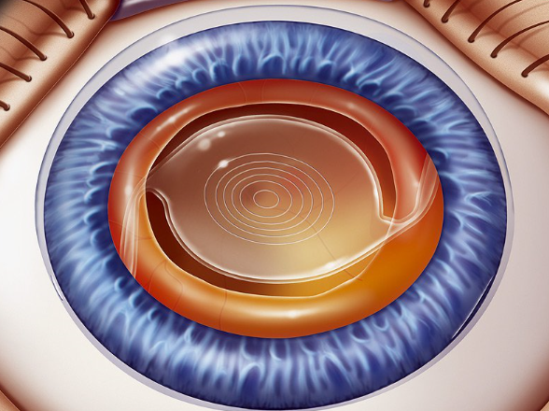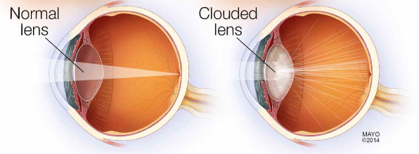

**Risks/Complications of Cataract Surgery**:

* Rare but serious risks:
  + 1/1000 risk of infection
  + 1/500 risk of retinal tears/detachments
  + 1/100 risk of capsular tear/instability
* More common things:
  + Posterior capsular opacification (“second cataract”) 30-40%
  + Floaters
  + Dry eye symptoms
  + Elevated eye pressures
  + Rebound iritis (inflammation in your eye)
  + Macular edema (swelling in the back of your eye)
  + Ptosis (eyelid drooping)
  + Glare/halos

You may be at an increased risk for other reasons (history of retinal detachments, FUCHS, macular degeneration, diabetes, etc.). These will be discussed with you at the time of your pre-op visit. The medications you will take after surgery are aimed at reducing some of these risks (i.e. antibiotics for infection risk, topical anti-inflammatory for macular edema and steroid drops for inflammation).

**Realistic Expectations**:

Our #1 priority in cataract surgery is your safety, which doesn’t mean we won’t do everything we can to give you the best vision possible. Though cataract surgery will not restore vision lost from other conditions like macular degeneration, glaucoma or diabetes damage, most patients end up seeing 20/25 or better at distance. All patients should expect to wear reading glasses after surgery for near vision. However, new lens technologies exist that can offer great distance and near vision. If you are interested in one of these multifocal or extended depth of focus lenses, we will discuss the options and pro/cons at your pre-operative appointment.

**Pre-Operative Appointments**:

* Your initial appointment(s) will include a cataract evaluation, dilated eye exam and pre-operative measurements.
* All these may be accomplished on one day or may be spread out over several visits. This will depend on the quality of your scans (eye dryness can greatly affect the quality), other eye conditions you may have (or that we find), our technician availability and, honestly, how far behind we are in clinic.
* You will likely be added to my surgical waitlist and I typically only know my schedule 4-6 weeks out. I will do my best to honor first come, first serve. I may call and offer you a last minute date. We often have cancellations and I’ll try to fill those spots. If that offered date does not work, your spot on the waitlist will not change.
* You will need a dilated eye exam within 30 days from your surgery date. You may be asked to come in for a repeat dilated exam.
* PAU= Pre-Admissions Unit. At BAMC, you must have a separate PAU appointment. This will be scheduled by one of our front desk staff. At Wilford Hall, you only need to fill out the “WHASC Pre-Surgical Checklist”. No PAU appointment is necessary at Wilford Hall
* You may need to pick-up eye drops before surgery. One of these drops will be used for the three days prior to surgery (see below).

**Medications**:

* Nepafenac/Nevanac **(GRAY top):** Instill 1 drop only in operative eye 3 times daily until bottle is empty (or until your one month appointment) starting at week two
  + *3 days prior to surgery*: Instill 1 drop only in operative eye ___3___ times daily
* Moxifloxacin/Vigamox **(TAN top)** or Polytrim **(WHITE top):** Instill 1 drop only in operative eye 4 times daily until bottle is empty
* Difluprednate/Durezol or Pred Forte **(PINK or WHITE top):** this drop should be **shaken** prior to use.
  + Week 1: Instill 1 drop only in operative eye ___4___ times daily
  + Week 2: Instill 1 drop only in operative eye ___3____ times daily
  + Week 3: Instill 1 drop only in operative eye ___2___ times daily
  + Week 4: Instill 1 drop only in operative eye ___1____time daily
* Pain medication as needed: Acetaminophen/Tylenol for mild to moderate discomfort after surgery at manufacturer’s recommended dose. See below for severe/worsening pain.
* Please separate all drops by 3 minutes

**Post-Operative Expectations:** Following surgery it is normal to have any combination of the below symptoms. Please see precautions section for any deviation from the below symptoms.

* Blurry vision—the blurriness should continue to improve with time and your post-operative eye medications
* Redness—It is common to have mild redness or even spots of blood on the white part of your eye; however, the redness should only improve and should not worsen
* Mild to moderate discomfort— eye pain/gritty, foreign body sensation—however, the pain should be controllable with acetaminophen/Tylenol and should not worsen

**Post-Operative Activity Restrictions**:

* Do NOT rub your operative eye.
* Eye protection (the provided clear shield/sunglasses or your old glasses) should be in place at all times during the day.
* Your eye shield should be taped in place over your operative eye prior to going to bed to prevent inadvertent eye rubbing while sleeping.
* You may shower but avoid getting soap/shampoo directly in the eye. Also, do not completely submerge face under water.
* No swimming for 2 weeks.
* Avoid strenuous activity, heavy lifting, bending at the waist to lift for at least 1 week.
* No eye make-up for 2 weeks.

**Precautions:** Please go directly to our Emergency Department if you experience any of the following:

* Severe pain and/or redness that is worsening after surgery and not relieved by over the counter acetaminophen/Tylenol
* Flashes of light, increased floaters, or a dark curtain/veil in your vision
* Fever of 101 degrees F or greater
* Persistent nausea or vomiting

**Follow-up Appointments:**

* Postoperative week #1: __________________________________________________
* Postoperative month#1: _________________________________________________

**Online Resources:** Please visit my website to learn more. You can learn more about cataract surgery, as well as other types of surgeries we offer. You will also find a “Patient Experiences” page that has posts from other patients. Feel free to share your experience afterwards!

**Contact:** It truly has been an honor to be your surgeon. If you have any concerns, please feel free to call/text me @ (214)-385-9611

Bryant Giles, DO, CPT, USA

These tables are intended to help you keep up with your drop regimen. Please check mark each time you use each drop. Remember your drops are vital to your healing process and your visual outcome. Please bring this with you at each follow up appointment.

On post-op day #1, you will get a new chart, just in case.

|  |  |  |  |  |  |  |  |
| --- | --- | --- | --- | --- | --- | --- | --- |
| **Vigamox**  **(Tan)** | Day 1 | Day 2 | Day 3 | Day 4 | Day 5 | Day 6 | Day 7 |
| Week 1 | o o o o | o o o o | o o o o | o o o o | o o o o | o o o o | o o o o |

|  |  |  |  |  |  |  |  |
| --- | --- | --- | --- | --- | --- | --- | --- |
| **Nevanac**  **(Gray)** | Day 1 | Day 2 | Day 3 | Day 4 | Day 5 | Day 6 | Day 7 |
| Week 1 | - | - | - | - | - | - | - |
| Week 2 | o o o | o o o | o o o | o o o | o o o | o o o | o o o |
| Week 3 | o o o | o o o | o o o | o o o | o o o | o o o | o o o |
| Week 4 | o o o | o o o | o o o | o o o | o o o | o o o | o o o |

*Continue this medication 3x/day until the bottle runs out

|  |  |  |  |  |  |  |  |
| --- | --- | --- | --- | --- | --- | --- | --- |
| **Pred Forte**  **(Pink)** | Day 1 | Day 2 | Day 3 | Day 4 | Day 5 | Day 6 | Day 7 |
| Week 1 | o o o o  o o o o | o o o o o o o o | o o o o o o | o o o o o o | o o o o o | o o o o | o o o o |
| Week 2 | o o o | o o o | o o o | o o o | o o o | o o o | o o o |
| Week 3 | o o | o o | o o | o o | o o | o o | o o |
| Week 4 | o | o | o | o | o | o | o |

*Shake well